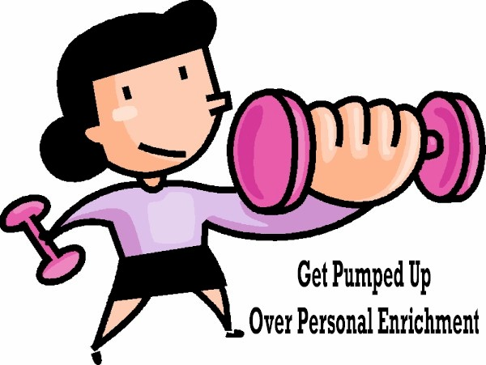

Helen Luckenbaugh
Personal Enrichment Program Manager
55 Woodland Avenue
York, PA 17404
(717) 848-6095

I’m not much of an “exercise chick”, but I do get excited over the importance of Personal Enrichment. By getting your chapters “Pumped Up” in the Personal Enrichment areas, the members are gaining confidence. All of these areas build confidence in the work place, at home, and with your friends. Ok ladies, let’s make President Terry proud and get “Pumped Up”!

GOALS:
- Conduct training on how to certify in PE areas
- Make PE forums fun times
- Stay in contact with National Counterpart
- Have articles in all PA Pride Mailings

PERSONAL ENRICHMENT AREAS:

- Effective Speaking
- Effective Writing
- Effective Listening
- Teambuilding
- Leadership

EMPHASIS MONTHS:

- AUGUST ~ Teambuilding
- NOVEMBER ~ Leadership
- JANUARY ~ Effective Speaking, Writing, Listening & Leadership

Send your forms to me and I will be awarding “Pumped Up” incentives for those members who certify in the emphasis months.

PA COMPETITIONS AND TOPICS:

Effective Speaking Guidelines:

- Topics to be announced
- 4-6 minutes in length
- Stat sheet sent to me including name, address, phone number, chapter and title of speech. Note: your title of your speech should be different from the topic provided.
- Deadlines: October 31, 3008 & April 30, 2009

Effective Writing Guidelines:

- Topics to be announced.
- 300-500 words, double spaced, single sided, 12 point font.
- Essay and stat sheet to be sent to me including name, address, phone number, chapter and essay title. Note: your topic for your essay should not be the same as the topic and is not included in the number of words.

National Competitions and Topics:

Upon receiving this information from National, I will be providing the topics and guidelines to each chapter.

