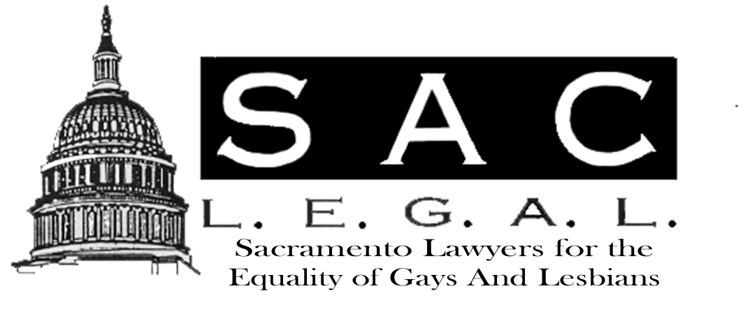

Newsletter
January / February 2003
2002/2003
Board of Directors

Marc B. Koenigsberg
Co-Chair
M. Jane Pearce
Co-Chair
Jay Kirkman
Secretary
Dianne Robbins
Treasurer
John Bennett
Jarrod Burch
Victoria Ciganda
Andrea Jackson
K C King
Burns Vick
Alayna Waldrum
Dawn Whitney

NOTE FROM THE CO-CHAIR
By M. Jane Pearce

Happy New Year. This is a note from your other co-chair. Marc and I will be alternating the Notes throughout the year to, hopefully, keep you informed, interested and involved.
The Holiday Party at Celestin’s was a lot of fun and well-attended. We welcomed new faces and greeted old friends. Justice Art Scotland and his wife attended and asked to be invited back next year. Many students took a break from exams to join us as well. Thank you to Marc and John Bennett for another great party. To those of you who did not make it, next year is a must.
Many new opportunities are developing this year for your involvement. I ask that each member seriously consider contributing to one Sac L.E.G.A.L. project or event or newsletter article this year. The following are a few in the works. If you have other ideas please share them with a Board member. The Protect and Defend Project to bring the Constitution and government lessons to area high schools is aiming for a Spring start-up. Sac L.E.G.A.L. is one of many groups participating in this program of Judge Damrell’s. If you need more information, contact Dianne Robbins. If you are interested in participating in a clinic serving gay clients, by supervising law students or providing direct advice yourself, please contact me or K C King. This one is in early stage development and will depend on our member interest.
Two educational programs are planned for the near future. The first is an MCLE event on employment law, planned for late spring. The other is geared more to the general public and will cover domestic partnerships in early summer. Details will be provided soon. Interested in helping with either one? Contact Victoria Ciganda, Dawn Whitney or me.

Inside This Issue
1 | Note from the Co-Chair
2 | 9th Circuit SEXUAL DISCRIMINATION Decision
3 | OPERATION PROTECT & DEFEND

Protection in the Workplace for Gays and Lesbians Comes to the 9th Circuit
By Marc B. Koenigsberg

In September 2002, the United States Court of Appeals for the Ninth Circuit, sitting en banc, held that an employee asserted a viable claim of discrimination based on sex under Title VII of the Civil Rights Act of 1964 where he alleged he was subjected to severe, pervasive, and unwelcome “physical conduct of a sexual nature” in the workplace, even though the employee also alleged the motivation for the discrimination was his sexual orientation. Rene v. MGM Grand Hotel, Inc. 305 F.3d 1061 (9th Cir. 2002).

Medina Rene, an openly gay man, worked as a butler on the 29th floor of the MGM Grand Hotel in Las Vegas from December 1993 until his termination in June 1996. He alleged that over the course of a two-year period, his supervisor and several of his fellow butlers subjected him to a hostile work environment on almost a daily basis. The conduct included whistling and blowing kisses at Rene, calling him “sweetheart,” telling crude jokes and giving sexually oriented joke gifts, and forcing Rene to look at pictures of naked men having sex. The conduct also included physical touching of a sexual nature. When asked at his deposition what he believed was the motivation behind the harassing, Rene responded that the behavior occurred because he is gay.

The District Court of Nevada agreed with Rene’s employer that Title VII’s prohibition of “sex” discrimination applied only to discrimination on the basis of gender and is not extended to include discrimination based on sexual orientation. MGM Grand Hotel’s motion for summary judgment was granted.

The 9th Circuit reversed, and recounted that physical sexual assault has routinely been prohibited as sexual harassment under Title VII. The Court surveyed cases finding such conduct violative of Title VII and found that none of those cases denied relief because the victim was, or might have been, a lesbian. The 9th Circuit stated the sexual orientation of the victim was simply irrelevant. The Court found that the physical attacks to which Rene was subjected, which targeted body parts clearly linked to his sexuality, were “because of…sex,” as that phrase is used in Title VII.

In reaching its conclusion, the Court relied on Oncale v. Sundowner Offshore Servs., Inc., 523 U.S. 75 (1998), stating the U.S. Supreme Court made it clear that first, a plaintiff’s action for sexual harassment cannot be defeated by showing that the perpetrator and the victim of an alleged sexual assault are of the same gender, and that second, offensive sexual touching is actionable discrimination even in a same-sex workforce. The 9th Circuit interpreted Oncale to mean that Jody Oncale did not need to show he was treated worse than members of the opposite sex; it was enough to show that he suffered discrimination in comparison to other men.

Since Rene’s case was filed, the Nevada legislature has enacted legislation prohibiting employment discrimination on the basis of sexual orientation. The Rene case still has widespread application as it applies to all nine states in the 9th Circuit, as well as Guam and the Northern Mariana Islands. The Seventh Circuit Court of Appeals decided a similar case, though apparently without the added facts of physical conduct, against the a gay employee. See Spearman v. Ford Motor Co., 231 F.3d 1080 (7th Cir. 2000), cert. denied, 121 S.Ct. 1656 (April 24, 2001). California has statutorily prohibited discrimination in employment on the basis of sexual orientation since 1992.

OPERATION PROTECT & DEFEND - THE CONSTITUTIONAL PROJECT

In response to alarming statistics showing that a significant percentage of high school and college students lack even a basic understanding of the Constitution and American Government, a committee of judges and lawyers assembled to address this disturbing trend. The committee's purpose was to examine the problem and determine how lawyers and judges, each having taken an oath to "protect and defend" the Constitution of the United States, could fulfill their civic and professional responsibility and address this widespread ignorance. The goal was educate students who would be future voters and jurors, as well as to renew interest in American history and civic values.

Following nearly a year of research and meetings with school officials, teachers, and students, the committee identified certain programs to be implemented in 2002-2003, and a framework for Protect & Defend to continue annually. The projects proposed were a civics lecture, a writing contest with scholarships and awards, and an in-class dialogue with students, modeled after Justice Kennedy's Dialogue on Freedom. In 2002, the boards of the Federal Bar Association and Sacramento County Bar Association each voted unanimously to sponsor Protect & Defend.

A Teacher Advisory Committee composed of civics and history teachers from local school districts is assisting in the development and implementation of the programs in the public schools. The steering committee, in cooperation with the schools, has planned a three-part civics program for the Spring of 2003. Part One of the program is a civics lecture in March 2003, delivered by this year's inaugural guest lecturer Mark Curriden, co-author of Contempt of Court: The Turn of the Century Lynching that Launched 100 Years of Federalism. The writing contest, Part Two of the program, will invite 12th graders to compete for scholarships and cash prizes by submitting original essays and creative works on historical and legal topics, drawing from Curriden's book and lecture. Finally, in April 2003, with the assistance of the local bar associations, the lawyers and judges plan to hold an interactive civics dialogue with high school students in their classrooms.

Sac LEGAL was specifically invited to participate in this important and exciting project, demonstrating the notice and respect that our organization is garnering in the community. If you would like more information about Protect & Defend, or would like to volunteer your time, please contact Dianne Robbins by e-mail at drobbesq@sbcglobal.net.

MEMBERSHIP DIRECTORY DEADLINE
Sac L.E.G.A.L.’s Membership Directory is scheduled to be printed this year in early spring. In order to make sure that you are included in the Directory, you need to renew your membership by March 1st. Additional copies of the Sac L.EG.A.L. Membership Directory will be printed so that they will be available for distribution at the events Sac L.E.G.A.L. will be participating in. Inclusion in the Directory is important because it can help you build those important contacts with other local attorneys in all kinds of practice areas, government agencies and the legislature. For those of you in private practice, it can also be a great source for referrals.

Early renewal also helps the board of directors budget for the coming year and to plan more events and activities. So go grab your membership renewal form and mail it in today. If you lost your renewal form among the many important papers you have to manage, you can always go to our web site at
www.geocities.com/westhollywood/park/3103
and obtain a new form.

Do it now while you are thinking about it.

