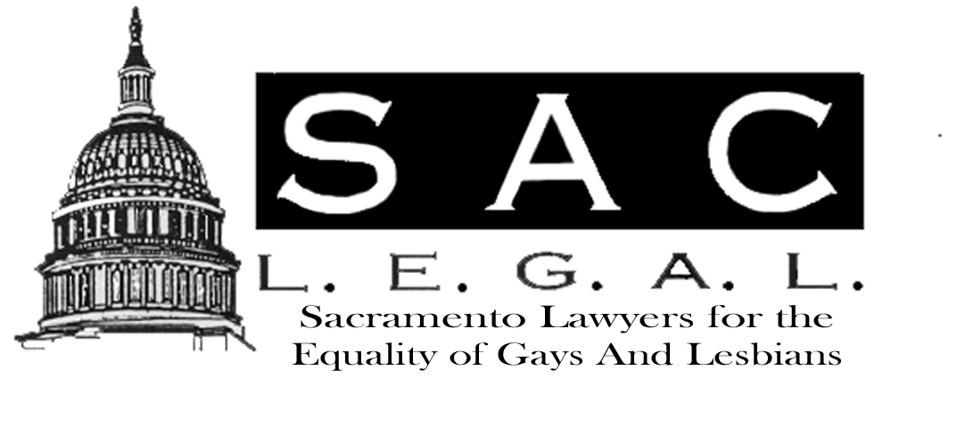

Newsletter
November / December 2002
2002/2003
Board of Directors

Marc B. Koenigsberg
Co-Chair
Jane Pearce
Co-Chair
Jay Kirkman
Secretary
Dianne Robbins
Treasurer
John Bennett
Jarrod Burch
Victoria Ciganda
Andrea Jackson
K C King
Burns Vick
Alayna Waldrum
Dawn Whitney

NOTE FROM THE CO-CHAIR
By Marc B. Koenigsberg

First off, I would like to take this opportunity to thank outgoing Co-Chair Dianne Robbins for her countless hours of work and dedication in getting Sac L.E.G.A.L. to the point it is at today. In the last year, Sac L.E.G.A.L. has gone from a bar association on the margins to one with increased visibility and respect in the Sacramento legal community. Examples of the accomplishments of Sac L.E.G.A.L. this past year include a very well-attended Spring Membership Mixer at the home of Professor Larry Levine, the staffing of a table at the Freedom Fair, a summer BBQ at the home of J.R. McCallum, the support of important legislation, the organizing of the 2nd Annual NCLR/Lambda Legal Fundraiser, and a marked presence at the annual Unity Bar Dinner.
Additionally, Sac L.E.G.A.L. was recently contacted by Justice Arthur Scotland for our organization’s endorsement of the appellate court justices running for re-election. As further evidence of our increasing stature in the community, Sac L.E.G.A.L. was invited to send a representative to serve on the steering committee to U.S. District Court Judge Frank Damrell’s civic education project called “Protect and Defend – The Constitution Project.” Look for details of this project, and how you can participate, in future issues of the newsletter.
Needless to say, I have greatly enjoyed working with Dianne over the last year as Co- Chair and look forward to working with her in the coming year in her role as Treasurer. My new Co-Chair for the 2002-2003 membership year is Jane Pearce, who brings with her extensive experience in other organizations and energy and determination to take
Continued on Page 2
Notes from the Co-Chair
Continued from Page 1
Sac L.E.G.A.L. even further.
Like last year, this year promises to be a success. The Sac L.E.G.A.L. Board has voted to become a member of the National Lesbian and Gay Law Association, which is an affiliate of the American Bar Association and which organizes the annual Lavender Law conference. This year Sac L.E.G.A.L. plans an MCLE event, the 3rd Annual NCLR/Lambda Legal fundraiser in September 2003, and continued representation on the Sacramento County Bar Association’s County Bar Council.
As you will note in the flyer included in this issue of the newsletter, this year’s Holiday Party promises to be one of the most outstanding yet. The festivities will be on Friday, December 13, 2002 at the Voodou Lounge at Celestin’s Restaurant from 5:30 p.m. to 7:30 p.m. We encourage all members to attend. This is one event you won’t want to miss.
Also included in the newsletter is this year’s membership application. After much discussion among the Board, we decided to increase membership $10 to $45 for general membership (regardless of whether a member is an attorney or not). The reasons for the increase include the fact that there has not been in an increase in many years, but more importantly because as Sac L.E.G.A.L. continues to increase its services to its membership and its participation in the greater community, additional funding is necessary. For those wishing to lend additional support, we have created a sustaining level of membership of $100. Those choosing to be sustaining members will receive recognition of their support in the Membership Directory and other publications, and in a newsletter new column called “Member Profiles.” In another change, membership for students at area law schools will be free.

With Jane, I look forward to an exciting year for Sac L.E.G.A.L. of increased membership, activity, and visibility. Please join us at the Holiday Party on December 13th to kick off the start of another great year.

Inside This Issue
1 | Note from the Co-Chair
2 | WHY ARE WE HERE?
3 | JOHN BENNETT RECOGNIZED
4 | JOB OPPORTUNITIES

WHY ARE WE HERE?
A LITTLE GAY HISTORY
By Dianne Robbins

In October 25th Sacramento Bee, I read an obituary of gay activist Harry Hay, who died October 24th at the age of 90. I was pleased to see the word “gay” in a mainstream paper headline, and it inspired me to do a little research. I think it’s important to remember our history, and those who paved the way for us, who are responsible for the fact that we live in relative safety and equality today.

In 1951, Harry Hay founded the Mattachine Society of New York. Mattachine was the first organization in the United States dedicated to furthering the cause of gay rights. The word “mattachine” is derived from the Italian “mattachino,” meaning a court jester who dared to tell the truth to the king. Depending on whom you listen to, the name was also derived from the Arabic “matachin” meaning to mask oneself, and was intended to symbolize the fact that gays were a masked people, unknown and anonymous.

Relying on volunteers and donations, the Mattachine Society of New York (MSNY) provided a wide variety of services, and engaged in a multitude of activities in service to the gay community. With a goal of serving the needs of all homosexuals, the MSNY provided legal, medical and mental health referrals, sponsored speakers and discussion groups, canvassed political candidates on their views on issues important to the gay community, and surveyed employers. The MSNY also lobbied for revision of laws on all levels discriminating against gays in housing and employment, honorable discharge for gay veterans, the decriminalization of consensual sodomy, and an end to police harassment. During the 1950’s, MSNY grew to include chapters in Boston, Chicago, Denver, Philadelphia and Washington, D.C. The parent organization moved its headquarters to San Francisco in 1961, at the same time its affiliates in other cities became independent organizations. After 36 years, the Mattachine Society officially
Continued on Page 3
Why Are We Here?
Continued from Page 2
disbanded in 1987.

The roots of the Mattachine Society can be seen in many of the important organizations operating today. Organizations like Lambda Legal Defense, National Gay and Lesbian Task Force, National Center for Lesbian Rights, Gay and Lesbian Anti-Defamation League, Human Rights Campaign, California Alliance for Pride and Equality, as well as local organizations like Hand to Hand, Breaking Barriers and (dare I compare?) Sac LEGAL continue the works started by men like Hay.

Reading Hay’s obituary got me to thinking about my good friend, classmate and fellow Sac LEGAL member Jim Gilkison, who died a year ago this month. Jim didn’t found a gay rights organization, and he didn’t live to be 90. Jim and I started law school together in 1996. Due to a degenerative eye condition, Jim had to transfer to the evening program, graduated in 2000, and passed the Bar on his first attempt. I was proud to be present when, on May 30, 2001, Jim was sworn in as an attorney and counselor at law. He was 47.

I like to talk about my friend Jim, his right wing politics and his unique philosophies: “The purpose of gay people is to care for animals and beautiful things,” he used to say. While I subscribe somewhat to Jim’s philosophy, I want to add that another of our purposes is to take care of each other. So, in honor of Harry Hay, my friend Jim and thousands of others, let’s keep up the good work.

John Bennett Receives Award
Sac L.E.G.A.L.’s First Annual Community Service Award was presented to John William Bennett at the Unity Bar Dinner on October 23, 2002 at the Sacramento Hilton. With hundreds of people from Sacramento County’s minority bar associations present, John was recognized for his continuing contributions to Sac L.E.G.A.L. and the Lesbian and Gay community.
John joined Sac L.E.G.A.L.’s board of directors in the fall of 2000 and has worked tirelessly since then, both within and outside the organization, to promote the equality of Gays and Lesbians.
Immediately after joining the board, John became our Webmaster and volunteered to chair our Events Committee. He was responsible for the development and success of Sac L.E.G.A.L.’s annual NCLR & Lambda Legal Defense Fundraiser and has been responsible for organizing and coordinating virtually all Sac L.E.G.A.L.’s social and fundraising events in the last two years.
John is also involved in other organizations working toward equality for Gays and Lesbians, and the Sacramento community in general. Among other things, he sits on the board of directors for CapPAC and is involved with the Sacramento County District Attorney’s Citizen’s Academy, designed to examine diversity and race issues within the framework of the criminal justice system. John has also spent many hours volunteering to elect candidates that support our community and has opened his home many times to host their fundraisers.
Congratulations John.

Job Opportunities
Bullivant Houser Bailey, is currently accepting
applications for one, perhaps two, 2-3 year associates for positions in business litigation. The firm is also accepting applications for experienced legal secretaries. Anyone interested can contact Marc B. Koenigsberg by phone or email at:
916-852-9100
Marc.koenigsberg@bullivant.net
AFL-CIO is offering a one-year fellowship to work in its legal department, which works on litigation, policy, legislative matters and assists with organizing campaigns. Salary range is $44,000-50,000 depending on experience. Send a resume, transcript, short writing sample, and a list of three references to:
Jonathan Hiatt, AFL-CIO
General Counsel, 815 Sixteenth St., NW, Washington, D.C. 20006.
Application deadline: open until filled.
The Tom Steel Post-Graduate Fellowship is offered by the Pride Law Fund. The mission of the fellowship is to fund a new lawyer to work on an innovative, public interest law project that serves the lesbian, gay, bisexual, transgender community. The award grant is $25,000 - $35,000. Applications must be postmarked no later than December 31, 2002. Visit: www.pridelawfund.org.
Americans United for the Separation of Church and State (in D.C.) is seeking applicants for its one year Madison Fellowship. The fellow will assist with ongoing litigation and screen incoming complaints and conduct non-litigation advocacy work. Stipend is $35,000. Mail cover letter, resume, transcript, writing sample, and names of three references to:
Thelma Scott, Americans United
518 C Street, NE,
Washington, D.C. 20002.
Application deadline: December 14, 2002 or until filled.
The Public Interest Law Office of Rochester is sponsoring its Hanna S. Cohn Equal Justice fellowship again this year. The fellow will represent low-income clients in complex litigation and other areas of advocacy. The two-year fellowship pays $32,500 per year.
Applications can be downloaded at www.pilor.org.

The Public Interest Law Office of Rochester is sponsoring its Hanna S. Cohn Equal Justice fellowship again this year. The fellow will represent low-income clients in complex litigation and other areas of advocacy.

Pillsbury Winthroop is looking for an associate with2-4 years' litigation experience to work in their Sacramento office. Candidates should be highly motivated and have excellent academic credentials and writing skills.
If interested please contact Pillsbury Winthroop LLP at 916-329-4700

MEMBER HAPPENINGS

Have you been recently made partner? Are you recently partnered? Baby coming? Did you run to Vermont for a civil union? Did you win the lottery?
Our members enjoy hearing the positive happenings of other members. Please let us know so we can share the good news. Member events can be sent to our editor Todd Vlaanderen. at: RTVlaan@aol.com
ANNOUNCEMENTS

If you have any announcements, know of any job opportunities, or just have something to say. Please submit your information to us for inclusion in the Newsletter. Information for the January/February 2003 newsletter should be submitted by January 15th 2003 to Todd Vlaanderen. at: RTVlaan@aol.com

