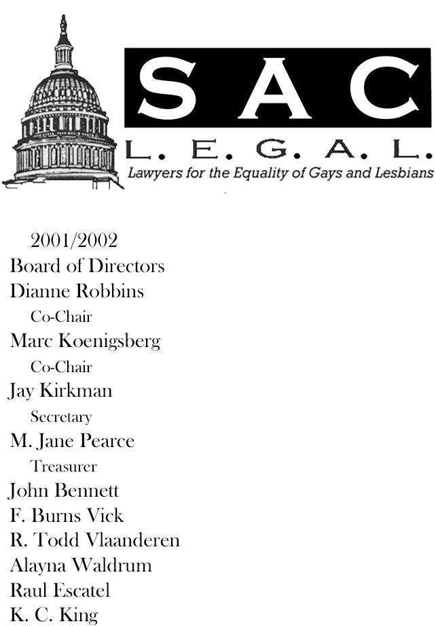

Newsletter
September / October 2002

NOTE FROM THE CO-CHAIR
By Dianne Robbins
Greetings Members:

Marc and I have been taking turns writing this column. Since this will be my LAST Note from the Co-Chair, he graciously consented to let me write this month. It has truly been a privilege to serve as Co-Chair of this organization for the last two years, and to work with such a creative and hard-working Board of Directors. I want to thank every single one of you for helping Sac LEGAL to have such a successful and productive year. And I must say a special thank you to my good friend and Co-Chair, Marc Koenigsberg, whose great ideas and teamwork have really made this job fun. (Don’t forget to catch Marc in Paperclip Messiah, the current Lambda Players production, playing through October 19.)

One of the most significant expansions of Sac LEGAL in the last two years has been the development of our now annual joint fundraiser for NCLR and Lambda. It was fabulous to see so many of you at the Second Annual Tipping the Scales for Justice. We were very fortunate to have so many celebrities among us, and I was particularly pleased that both Tracy Moore, Lambda Legal’s Western Regional Director, and NCLR Executive Director Kate Kendell attended personally this year. It was a great time for a great cause, and one I hope will continue for many years to come.

In addition to our fundraiser, Sac LEGAL has been growing in activities and recognition. Our membership has more than doubled in the last two years. We have
Continued on page 4
NOTE FROM THE CO-CHAIR
Continued from page 1
become more involved in the Sacramento County Bar, the Unity Bar and were recently approached and asked to endorse the Third District justices on November’s ballot. But most important – people are actually learning what the name Sac LEGAL stands for!

ANNUAL MEETING
Your current Board’s term is coming to an end, and you the members will be electing the 2002/2003 Board of Directors at the Annual Meeting October 16. More details inside. I hope you will all attend the Annual Meeting, come elect next year’s Board, and help lead Sac LEGAL as we continue to grow.

UNITY DINNER
Unity Dinner 2002 is happening October 23 at the Sacramento Hilton. We almost filled two tables last year, and we’d like to have an even better turnout this year. If you are interested in purchasing a seat at one of the Sac LEGAL tables, please e-mail your reservations to John Bennett. It was a really good event last year, so I hope to see a lot of you there.

Inside This Issue
1 | Note from the Co-Chair
2 | INTERNATIONAL PERSPECTIVE
2 | UPCOMING EVENTS
3 | NEW INHERITANCE RIGHTS FOR DOMESTIC PARTNERS
4 | MEMBER HAPPENINGS & JOB OPPORTUNITIES
Upcoming Events

October 9th – 12th
Sacramento International Gay & Lesbian Film Festival
7:00 P.M.
Tower & Crest Theaters
Tickets available at the door.

October 14
Second Annual Bill Smith Memorial Lecture
5:30 p.m.
UC Davis’ Martin Luther King, Jr. Hall, Room 1008
Shannon Minter, Legal Director of the National Center for Lesbian Rights is speaking on transgender equality.
October 16, 2002
Sac LEGAL Annual Membership Meeting
5:30 p.m.
Lambda Community Center
1927 L Street

October 18, 2002
Annual CAPPAC Dinner
6:30 p.m.
Tsakopulos Library Galleria
828 I Street
Ticket price $95.00 each
If interested in sitting at one of the Sac LEGAL tables, please e-mail your RSVP to John Bennett at johnwb50@yahoo.com
October 23, 2002
Annual UNITY Bar Dinner
6pm no host bar, 7pm dinner
Sacramento Hilton
2200 Harvard Street
Cost is $45, $30 for students.
If interested in sitting at one of the Sac LEGAL tables, please e-mail your RSVP to John Bennett at johnwb50@yahoo.com

November 2, 2002
Capital Unity Council Dinner
5:30 P.M. Reception
6:30 P.M. Dinner
Sheraton Grand Hotel
1230 J Street

INTERNATIONAL PERSPECTIVE
By M. Jane Pearce

Few would argue that gay civil rights have not made significant strides in California in the last two years. We have a domestic partnership law with a few teeth in it. Sacramento County employees have benefits for their partners. A few trial judges have made courageous decisions extending rights to gay litigants.

And I am thrilled with the progress and remain optimistic that the law and the culture will continue to change in a positive direction. Part of that optimism is in knowing Sac LEGAL members who work very hard to effect that change. Another part of that optimism stems from having recently returned from a vacation that revived me on many different levels.

I visited perhaps the two most gay-friendly cities in Europe. It wasn’t planned that way. I was in Amsterdam and Berlin for different reasons, but I enjoyed the openness and acceptance that both provided. You can feel comfortable holding hands with your partner on any street. Myriad state benefits are available to gay couples.

It was a wonderful coincidence that the day I arrived in Amsterdam was the date for their gay pride parade: a lavender display of floats on boats down the canals. All people stopped to view and cheer the boats as they passed their section of town. I discovered the date for this event shortly before I left, as it was advertised on their web-site, alongside The Floriade, the once-a-decade flower expo which is what draws most visitors and was the object of my search. Amsterdam is also the site of the only monument in the world to honor gay victims of the Holocaust. Around the corner from the Anne Frank House, it is a simple, pink triangle of stone, jutting into the canal, with a sign designating it the Homomonument. Amsterdam is fun.

Berlin is very different. It is a sophisticated, complex and fascinating city where, indeed, anything goes and no one bats an eye. Once again
Continued on page 3
INTERNATIONAL PERSPECTIVE
Continued from page 2

the seat of the German government, it can sate your appetite, whether for politics, art, history or sex. The nightlife doesn’t discriminate.

Both cities provided a level of comfort unknown here outside of the Castro or parts of midtown Sacramento. Does cultural acceptance follow the law or does the law follow cultural acceptance?

In the domestic realm, the direction of United States law seems to be toward granting gay couples quasi-marital rights without calling it marriage. For now, the M word is clearly off-limits for other than a man and a woman. And maybe that’s fine. But it raises more questions.

California statute defines marriage as a personal relationship arising out of a civil contract between a man and a woman, but there have been no appellate decisions as to the validity of that definition. The Federal Defense of Marriage Act, passed in 1996, restricts marriage to opposite sex couples, and for federal benefit purposes, proclaims that states need not give full, faith and credit to same sex marriages licensed in other states.

This presents a departure from a long history in California of recognizing the validity of a union contracted outside of California as long as it was valid under the laws of the jurisdiction in which it was contracted. Common examples of such marriages always recognized by California, and thus requiring a divorce upon termination, are common-law, incestuous and even bigamous ones.

How would California view a same sex couple who married in the Netherlands? Or who joined in a Vermont civil union? We know the federal government would not recognize the Dutch as a couple under immigration law (only the Netherlands and six other countries do). More questions yet. Stay tuned; stay involved; and take a holiday to Europe.

New Intestate Inheritance Rights for Registered Domestic Partners
By R. Todd Vlaanderen

As you probably already know, Governor Gray Davis signed important California legislation, Assembly Bill 2216, creating intestate succession for registered Domestic Partners. Our congratulations and thanks go to Sac LEGAL member, David Van Der Griff. David is Assembly Member Keeley’s staff member who drafted the bill and worked tirelessly to get it passed and signed into law.

The bill will be effective July 1, 2003 rather than January 1, 2003 when most other legislation becomes effective. This delay was written into the bill in order to provide notice of the change in intestate succession to all of California’s registered Domestic Partners prior to its effective date. The California Secretary of State will send this notice sometime before March 1, 2003. Registered Domestic Partners should all review their estate plans and make any necessary changes as early as possible.

Essentially the law gives a surviving Domestic Partner the same share of their deceased Partner’s separate property as a surviving Spouse would inherit. Depending on the number and type of other heirs, the surviving partner will take all, one half or one third of the estate not already disposed of through a will or other estate-planning document. It is important to understand that this intestate share relates only to that portion of the estate that is not already disposed of through a will or trust. Each partner still has the right to provide in advance, through a will or trust, for their partner to inherit all or none of their property.

It is also important to recognize that there are still significant differences between spouse and domestic partner intestate succession. Unlike domestic partnerships, most property acquired during marriage in California is the community property of both spouses and is treated differently than separate property in intestate succession. The concept of community property has not been applied to domestic partners in California.
Continued on page 5
Intestate Inheritance
Continued from page 3
This is not necessarily a bad thing, just different. In certain respects, it gives domestic partners more options in disposing of their estates upon death, and is why it is still important to discuss and perform estate planning with our clients and with our partners.

While it does not provide the exact same inheritance rights as marriage, this legislation is a HUGE step toward equal and fair treatment for gay and lesbian domestic partners. It will provide a great deal of security for surviving domestic partners in situations where the couple did not execute any estate planning documents.

MEMBER HAPENINGS
John Bennett has been accepted by Alice Wong, Chief Deputy DA, to the District Attorney's 10-week course - Citizens Academy. This unique 10-week Academy will provide an important overview of the criminal justice system (role of law enforcement, district attorney and judicial system), as well as examine diversity and race issues within the framework of the criminal justice system.

Todd Vlaanderen will be speaking at this year’s California Sate Bar Annual Meeting in Monterey. He is part of an MCLE panel on business entity selection and formation in California.

Sac LEGAL member, Steve Muni has been selected by the State BAR of California to serve on the Bar's Committee on Sexual Orientation and Gender Identity Discrimination.
Job Opportunities

Bullivant Houser Bailey, is currently accepting
applications for one, perhaps two, 2-3 year associates for positions in business litigation. The firm is also accepting applications for experienced legal secretaries. Anyone interested can contact Marc B. Koenigsberg by phone or email at:
916-852-9100
Marc.koenigsberg@bullivant.net

AFL-CIO is offering a one-year fellowship to work in its legal department, which works on litigation, policy, legislative matters and assists with organizing campaigns. Salary range is $44,000-50,000 depending on experience. Send a resume, transcript, short writing sample, and a list of three references to:
Jonathan Hiatt, AFL-CIO
General Counsel, 815 Sixteenth St., NW, Washington, D.C. 20006.
Application deadline: open until filled.

The Tom Steel Post-Graduate Fellowship is offered by the Pride Law Fund. The mission of the fellowship is to fund a new lawyer to work on an innovative, public interest law project that serves the lesbian, gay, bisexual, transgender community. The award grant is $25,000 - $35,000. Applications must be postmarked no later than December 31, 2002.
Visit: www.pridelawfund.org.
The Lesbian & Gay Rights and AIDS Projects of the ACLU is seeking applicants for a one-year legal fellowship in New York City. The fellow will help with the litigation and legislative/policy work of the Projects. The LGR Project focuses on equal treatment and basic respect for lesbians, gay men, bisexuals and transgendered people. The AIDS Project was created to safeguard civil and constitutional rights of people with HIV. Salary is at the ACLU scale. Application deadline is November 15, 2002. Send a cover letter, resume, writing sample, transcript, and list of references to: James Esseks, Litigation Director ACLU Lesbian and Gay Rights & AIDS Projects 125 Broad Street, 18th Floor New York, New York 10004-2400 (212) 549-2650 (fax) jesseks@aclu.org.
Americans United for the Separation of Church and State (in D.C.) is seeking applicants for its one year Madison Fellowship. The fellow will assist with
Continued on page 5
Job Opportunities
Continued from page 4
ongoing litigation and screen incoming complaints and conduct non-litigation advocacy work. Stipend is $35,000. Mail cover letter, resume, transcript, writing sample, and names of three references to:
Thelma Scott, Americans United
518 C Street, NE,
Washington, D.C. 20002.
Application deadline: December 14, 2002 or until filled.
The Public Interest Law Office of Rochester is sponsoring its Hanna S. Cohn Equal Justice fellowship again this year. The fellow will represent low-income clients in complex litigation and other areas of advocacy.
The two-year fellowship pays $32,500 per year.
Applications can be downloaded at www.pilor.org.

Sac L.E.G.A.L.
1008 10th Street, #115
Sacramento, CA 95814

