* Washington Post *
January 10, 2005 Issue 3,467
Boy Scouts Go on Klondike Derby!
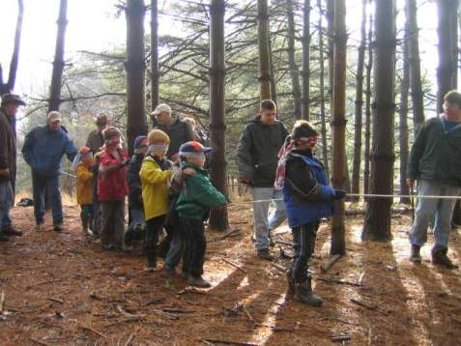
Last Saturday, January 8, 2005, The Boy and Cub Scouts of Maryland went to Patapsco State Park. The Cub scouts went on a trail that taught them about crossing to California for the Gold Rush. They preformed many activities like the one you see here. In that picture Cub scouts were holding onto a rope to get through a group of trees blind-folded. There were many other activities that the Cub scouts did.
There wasn’t only a trail for Cub Scouts though, there was a trail for Webelos and Boy Scouts! On the Boy scout trail boys learned how to light a fire with matches and without how to make a shelter out of sticks, string and brush and how to tie important knots at the beginning of different stations, Scout did their pack cheer. At each station, the scouts were awarded points part of those points were for their Pack cheer. One pack cheer goes “2, 4, 6, 8, 606 spirit is great! 1, 3, 5, 9, no matter what, we’re gonna’ shine! HUH!” Philip Ramis, a Webelos 2 in Den 1 Eagles of Pack 606 states “This derby is great fun! I especially liked making a Shelter”

Eric Meehan

Tsunami Victims Slowly Recover
After the tsunami devastated millions, Recovery is slowly recovering “We the Americans can help these people” President George W. Bush stated. Every little

Turn to page A6

Dow
24.03

12.04
SAT

