Muddy Klondike Derby

Written by Kevin Kim

At Patapsco Park, MD on a muddy day, cubscouts gathered for a Klondike Derby. On the
boy scout trail, a few of the activities there were match fires, matchless fires, knot tying (knot tying includes a few), care for pocket knives,

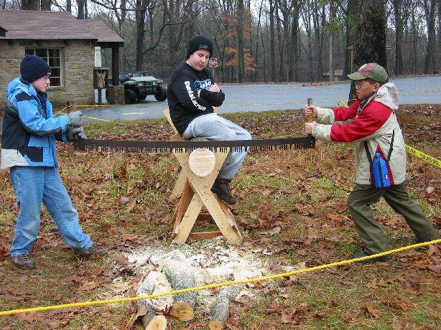
Two scouts learning how to use a two person saw.
and use of two person saw. Most of the scouts were having fun. Maybe a few didn't, but most of them looked like they were having a wonderful day.

