
SAN LUIS SMALLBORE ASSOCIATION
PO Box 1465, San Luis Obispo, CA 93406-1465

2006 COWBOY NRA RIFLE SILHOUETTE PROGRAM

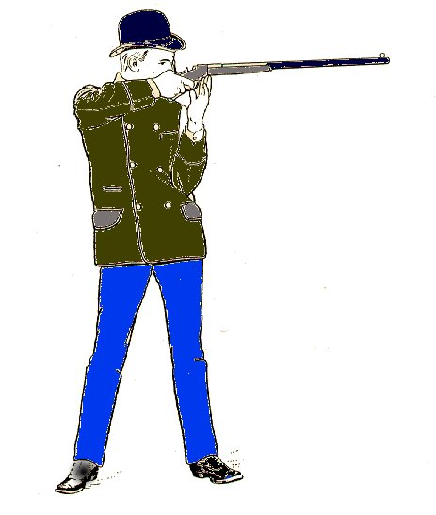

- Pistol Cartridge Lever Action Silhouette Rifle.

- Rifle or carbine

- Any rimmed, straight wall pistol cartridge* including
22 LR & 22 Magnum

- Magazine loading only.

- Open sights, receiver or tang sights manufactured for lever action rifles

- Aperture front sights may not be used. Post front sights only.

*(25/20, 32/20, 38/40, 44/40 ok)

40 Shot timed matches Knockdown silhouettes

- 22 Rim-Fire Silhouette Rifle

- Any pump, auto, lever action rifle with a tubular magazine.

- 22 Long rifle ammo only.

- All rounds loaded from the magazine

- Open sights, receiver or tang sights manufactured for these rifles

- Aperture front sights may not be used. Post front sights only.

10 Shots each: Chickens @ 40 meters, Pigs @ 50 meters, Turkeys @ 75 meters and Rams @ 100 meters.

NO DEFINITE MATCH SCHEDULE IS AVAILABLE AT THIS TIME.
PLEASE CALL TO CONFIRM MATCH DATES.

MATCH DIRECTORS ARE NEEDED.
WE WOULD LIKE TO GET THESE MATCHES STARTED AGAIN.
If you are interested in organizing and running a match or just participating, please call Frank Catherina (805) 489 9443 or Jim Tkach (805) 528-6353 from 8AM-8PM.

Sunday's programs start at 8AM with sign-up and practice followed by the rim fire matches.
The matches will start at 9AM and the center fire programs begin shortly after the completion of the rim fire events.

An award will be given to the Open Winner and for the First Place in each class. An additional award will be given for each additional five entries in a class after the first five. A handicap system will be used when classes are combined. For information please contact Frank Catherina at (805)-489-9443 between 8AM-8PM. Check out our website at http://www.geocities.com/ccfef/smallbore.html

San Luis Smallbore Association range is located off of Highway 1, between San Luis Obispo and Morro Bay. Turn off the highway at Gilardi Road at the CCFEF Shooting Range, go through the right hand gate and follow the road. Turn left at the next gate and come on in. All are welcome!




